**Mode Card Software Architecture Design**

Compliance with ASPICE, ISO 26262, ISO/SAE 21434 Standards

☑ ASPICE-1/2/3/4/5 □ ASIL-A/B/C/D □ CAL-1/2/3/4

Issued by Ford ECDX

|  |  |  |  |
| --- | --- | --- | --- |
| Prepared by | Jiawei Li | Audited by |  |
| Reviewed by |  | Approved by |  |
| Issue By | Jiawei Li | Receiver |  |
| Deposit address |  | | |
| Upstream doc. |  | | |
| Downstream doc. |  | | |
| Secret Request | N/A | Text Format | N/A |
| Expire Years | 2037 | Current State | Draft×baseline×publish√ |

**Change History**

| Version | | Date | Author | Approve | Changes |
| --- | --- | --- | --- | --- | --- |
| Current | New |
| --- | 0.1 | 2022.12.21 | Li Jiawei |  | Initial Version |
| 0.1 | 0.2 | 2023.01.03 | Li Jiawei |  | 1. add key component description of static architecture 2. add key sequence diagram |
|  |  |  |  |  |  |
|  |  |  |  |  |  |
|  |  |  |  |  |  |
|  |  |  |  |  |  |
|  |  |  |  |  |  |
|  |  |  |  |  |  |
|  |  |  |  |  |  |
|  |  |  |  |  |  |

List of content

1. Outline 5

1.1 Objectives 5

1.2 Reference documents 5

1.3 The definition of terms, abbreviations, and etc 5

2. Constraint Conditions 6

2.1 The Constraints of Hardware 6

2.2 The Constraints of Software 6

2.3 The Constraints of Manufacturing Process 6

2.4 The Constraints of Service and Maintenance After Shipment 6

3. Software Design 7

3.1 Software Static Architecture 7

3.1.1 External module dependencies diagram 7

3.1.2 Software Architecture Diagram 8

3.1.3 COMP_01: Custom Mode 9

3.1.4 COMP_02: Card Trigger 9

3.1.5 COMP_03: Card Executor 10

3.1.6 COMP_04: Card Terminator 11

3.1.7 COMP_05: Card Management 12

3.2 Software Dynamic Architecture 13

3.2.1 Function 13

3.2.1.1 Create a custom Card Mode 13

3.2.1.2 Run a Card Mode 14

3.2.1.3 Terminate a Card Mode 15

3.2.2 Safety Mechanism_ASIL 15

4. Detailed Interface 15

4.1 Component Interface 15

4.2 Hardware – Software Interface 15

5. Software control Strategy 16

5.1 Time Constrains Design and Estimation 16

5.2 Task Management 16

5.3 Interrupt Service Routines 16

5.4 Initialization Processing 16

5.5 Watch Dog 16

5.6 Shared Resources 16

6. Resource Estimation 16

6.1 Memory Size Estimation 16

6.2 CPU Load Estimation CPU 16

# 

# Outline

## Objectives

This is Mode Card SW design to guide developer to implement features, forwarding is forbidden without concurred by author

## Reference documents

| No. | Reference Document. | Version | Issuer | Reason. |
| --- | --- | --- | --- | --- |
| 1 | Mode Card 1.0 PRD 场景卡片_V1.0_20221210 | V1.0 | Geng Dekang |  |
| 2 | Camp Mode_PRD_V1.0_20221125 | V1.0 | Ni Anthony |  |
| 3 | Pet Mode 0.3 PRD_ 20221216 | V0.3 | Hu Lina |  |
| 4 | Battery Save Mode 0.1 PRD_ 20221214 | V0.1 | Hu Lina |  |

## The definition of terms, abbreviations, and etc

| No. | Terms and Abbreviations. | Meanings, Definitions and Official Name. |
| --- | --- | --- |
| 1 | Co., Ltd. | Company Limited |
| 2 | CPU | Central Processing Unit |
| 3 | e.g. | exempli gratia |
| 4 | I/O | Input/Output |
| 5 | ISR | Interrupt Service Routine |
| 6 | OS | Operating Software |
| 7 | RAM | Random Access Memory |
| 8 | ROM | Read Only Memory |
| 9 | RTOS | RealTime Operating Software |
|  |  |  |
|  |  |  |

# Constraint Conditions



## The Constraints of Hardware

* CX727 ICA Bench，including Silver Box, Display Screen, DSP & Cables
* CX821 Bench，including Silver Box, Controller Screen , Pano Screen, DSP & Cables

## The Constraints of Software

## The Constraints of Manufacturing Process

* N/A

## The Constraints of Service and Maintenance After Shipment

* N/A

# Software Design



## Software Static Architecture



### External module dependencies diagram

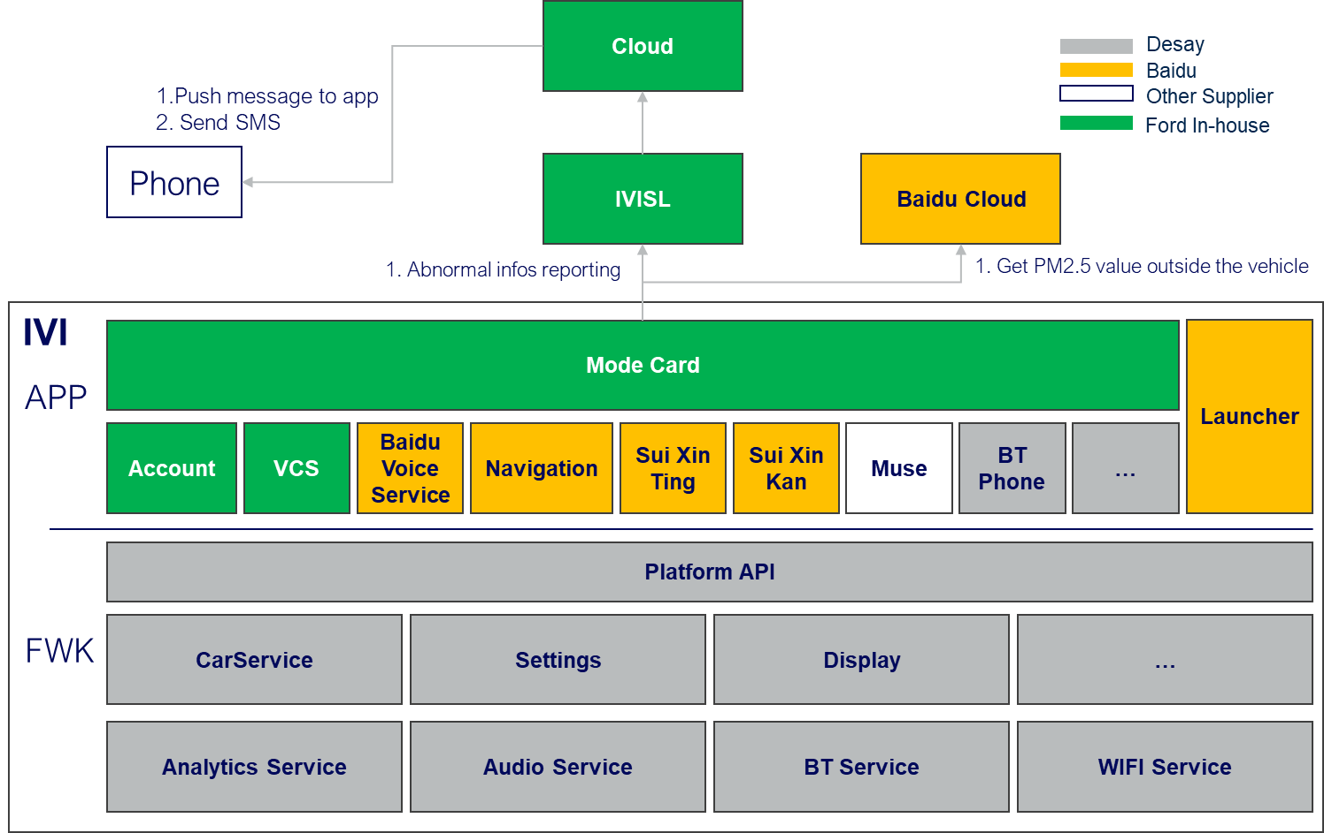

**CX727 ICA**

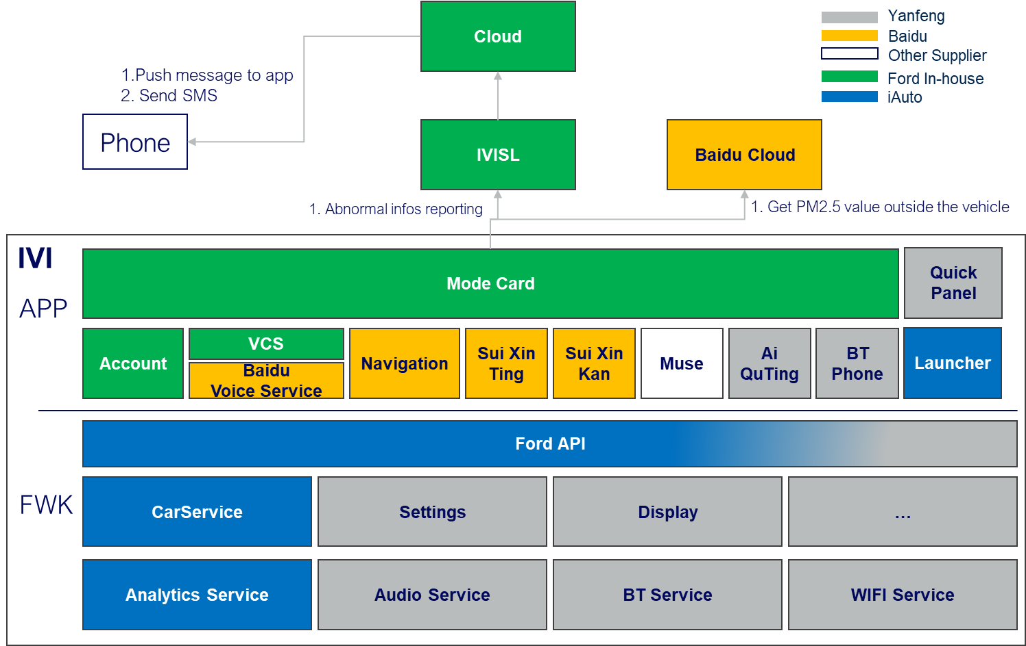

**CX821**

### Software Architecture Diagram

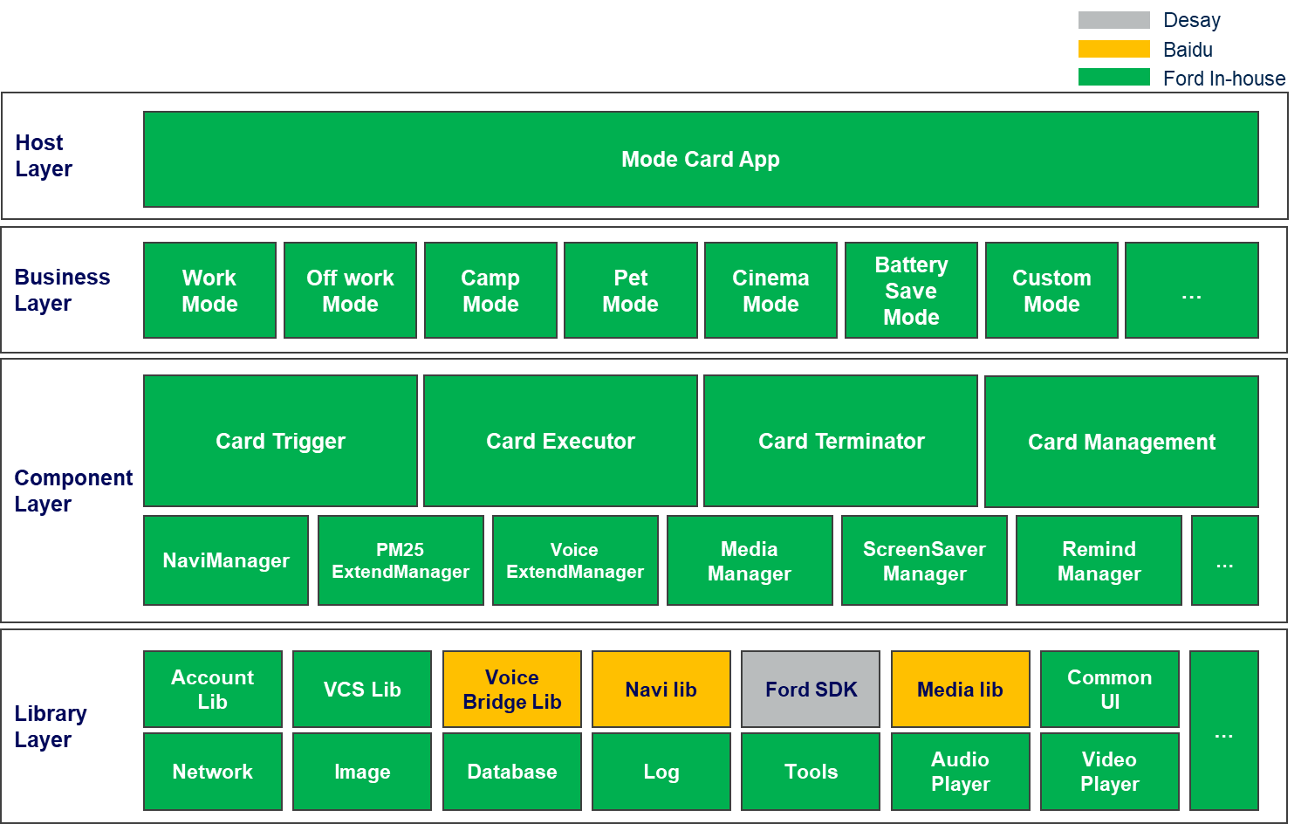

**CX727 ICA**

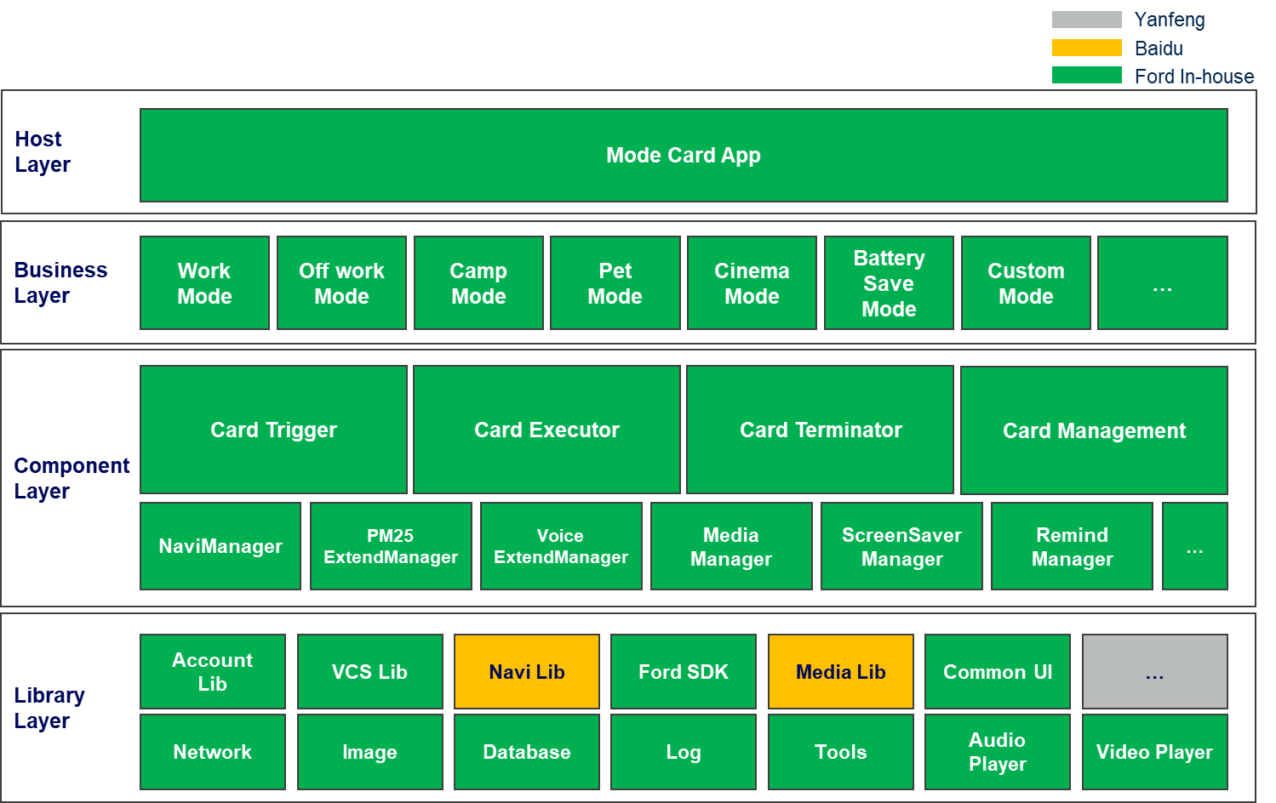

**CX821**

**四大核心组件：抽象Card Mode形成Card Trigger, Card Executor, Card Terminator, Card Management四大组件。**

**设计原则：**

**四大组件自包含，松耦合，标准化南北向接口，横向接口，可以组合创建任意卡片模式，灵活支持业务层的扩展。**

### COMP_01: Custom Mode

|  |  |  |
| --- | --- | --- |
| ID | | MODECARD_COMP_01 |
| Layer | | Mode Card Business Layer |
| Responsibility | | Custom Mode Component |
| Req Allocation | | 1. 展示自定义卡片列表页 2. 展示自定义卡片创建页 3. 创建自定义卡片 4. 保存自定义卡片 5. 编辑自定义卡片 6. 查询自定义卡片 7. 删除自定义卡片 |
| Source | | N/A |
| ASIL Class | | N/A |
| Resource Consumption | Flash | N/A |
| RAM | N/A |
| EEPROM | N/A |
| CPU | N/A |

### COMP_02: Card Trigger

|  |  |  |
| --- | --- | --- |
| ID | | MODECARD_COMP_02 |
| Layer | | Mode Card Component Layer |
| Responsibility | | Card Trigger Component |
| Req Allocation | | 1. 设置语音触发方式（语音打开） 2. 设置运行周期（一次/重复） 3. 设置运行前询问开关 4. 设置时间触发器（时间范围监听） 5. 设置位置触发器（监听达到终点距离，时间） 6. 设置环境触发器：   查询/监听车内/车外PM2.5，  查询/监听车内/车外温度   1. 设置车辆信信息触发器   查询/监听续航里程，电池电量，车速，档位，充电状态，  预计充电时间，电子手刹，雨量等级，光亮等级，点火状态   1. 设置乘员信息触发器   查询/监听主副驾安全带，后排左中右安全带，副驾状态   1. 设置门窗信息触发器   查询/监听主副驾门状态，后排左右门状态，前舱盖状态，后备箱门状态，全车门锁状态，主副驾车窗状态，后排左右车窗状态   1. 设置导航信息触发器   查询/监听导航状态，所处路段，限速信息 |
| Source | | N/A |
| ASIL Class | | N/A |
| Resource Consumption | Flash | N/A |
| RAM | N/A |
| EEPROM | N/A |
| CPU | N/A |

### COMP_03: Card Executor

|  |  |  |
| --- | --- | --- |
| ID | | MODECARD_COMP_03 |
| Layer | | Mode Card Component Layer |
| Responsibility | | Card Executor Component |
| Req Allocation | | 1. 空调管理   空调开关，AUTO,温度，风量，吹风模式，循环模式，后窗加热，主副驾座椅空调，方向盘加热，香氛开关，香氛模式，香氛浓度   1. 灯光管理   氛围灯开关，氛围灯颜色，氛围灯亮度，氛围灯模式，日行灯   1. 影音管理   随心听，随心看，Muse，爱趣听   1. 座椅管理   主副驾座椅位置，主副驾按摩开关，主副驾按摩模式，主副驾按摩强度（仅CX821）   1. 设置管理   分屏，熄屏，媒体音量，提示音量，语音音量，电话音量，手机私密模式，驾驶模式，音区，定时，闹铃音，蓝牙连接，无线连接 |
| Source | | N/A |
| ASIL Class | | N/A |
| Resource Consumption | Flash | N/A |
| RAM | N/A |
| EEPROM | N/A |
| CPU | N/A |

### COMP_04: Card Terminator

|  |  |  |
| --- | --- | --- |
| ID | | MODECARD_COMP_04 |
| Layer | | Mode Card Component Layer |
| Responsibility | | Card Terminator Component |
| Req Allocation | | 1. 手动停止卡片 2. 语音停止卡片 3. 条件触发退出卡片 |
| Source | | N/A |
| ASIL Class | | N/A |
| Resource Consumption | Flash | N/A |
| RAM | N/A |
| EEPROM | N/A |
| CPU | N/A |

### COMP_05: Card Management

|  |  |  |
| --- | --- | --- |
| ID | | MODECARD_COMP_05 |
| Layer | | Mode Card Component Layer |
| Responsibility | | Card Management Component |
| Req Allocation | | 1. 生成一个卡片实体 2. 设置卡片名称 3. 设置卡片运行触发器（运行方式，运行触发条件，运行周期，运行前询问） 4. 设置卡片执行器 5. 设置卡片终止器 6. 保存卡片配置 7. 查询卡片配置 8. 重置卡片配置 9. 删除卡片 10. 卡片运作状态 |
| Source | | N/A |
| ASIL Class | | N/A |
| Resource Consumption | Flash | N/A |
| RAM | N/A |
| EEPROM | N/A |
| CPU | N/A |

## Software Dynamic Architecture



### Function



#### Create a custom Card Mode

Create a custom Card Mode

|  |  |
| --- | --- |
| DemoMode_Sequence_01 | Functions  Create a custom Card Mode |
| Operation outline  操作概要 | 1. 创建一个空白卡片 2. 设置卡片名称 3. 设置卡片运行方式 4. 设置运行触发条件 5. 设置运行周期 6. 设置运行前询问 7. 设置运行任务 8. 设置终止方式 9. 保存卡片 |

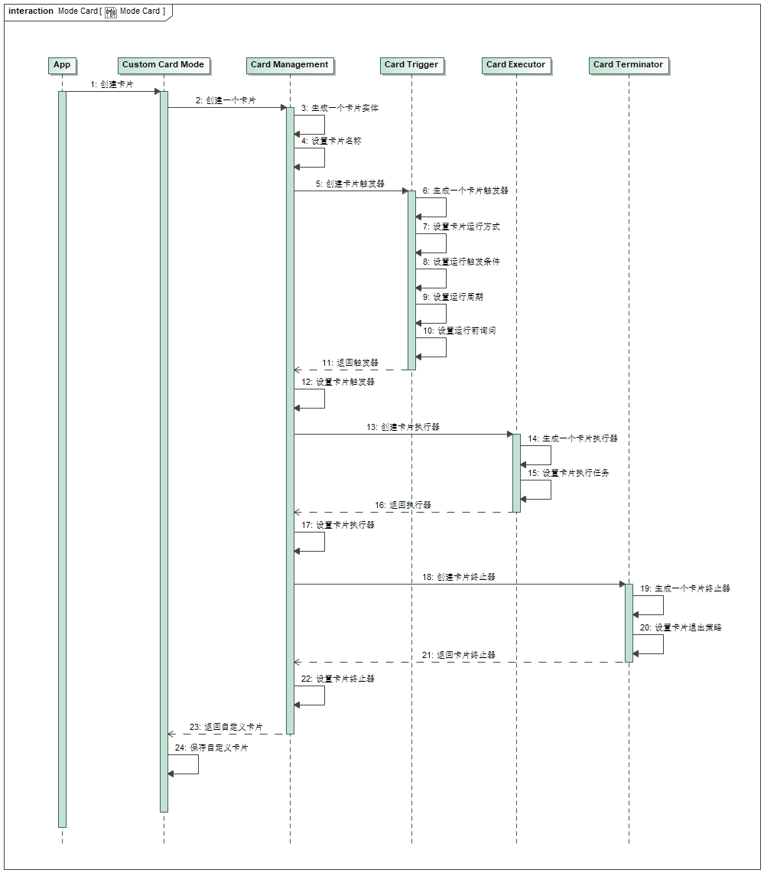

#### Run a Card Mode

Run a Card Mode

|  |  |
| --- | --- |
| DemoMode_Sequence_01 | Functions  Create a custom Card Mode |
| Operation outline  操作概要 | 1. 触发运行条件 2. 运行环境校验 3. 运行提示 4. 运行Card Mode 5. 执行卡片任务 |

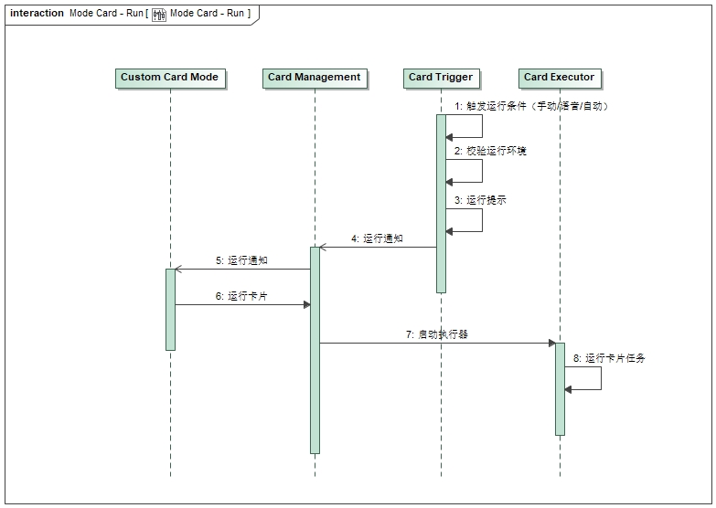

#### Terminate a Card Mode

Terminate a Card Mode

|  |  |
| --- | --- |
| DemoMode_Sequence_01 | Functions  Create a custom Card Mode |
| Operation outline  操作概要 | 1. 触发终止条件 2. 终止提示 3. 终止Card Mode 4. 恢复座舱设置 |

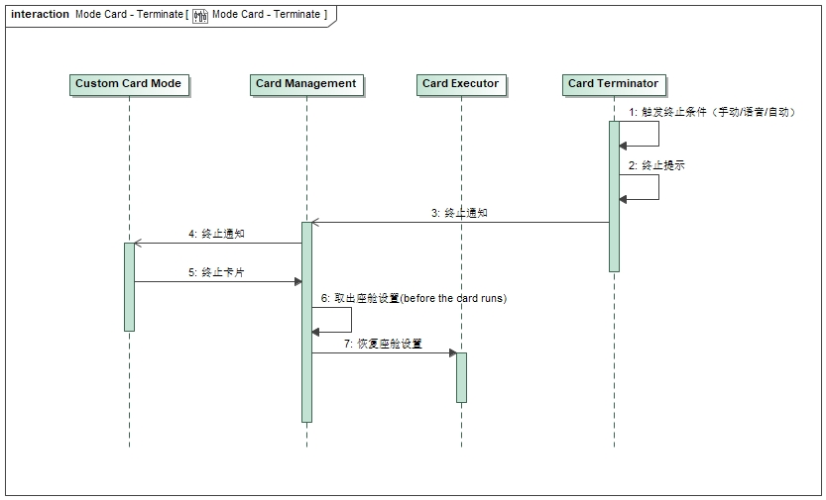



### Safety Mechanism_ASIL

N/A

# Detailed Interface

## Component Interface

## 4.2 Hardware – Software Interface

N/A

# Software control Strategy

## Time Constrains Design and Estimation



## Task Management

N/A

*I*

## Interrupt Service Routines

N/A

## Initialization Processing

## Watch Dog

N/A

## Shared Resources

N/A

# Resource Estimation

## Memory Size Estimation

## CPU Load Estimation CPU